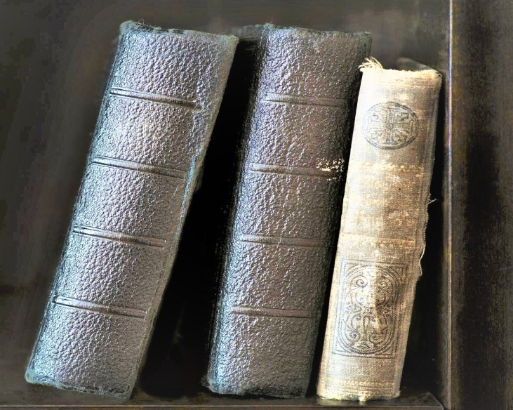

**SARDAR PATEL UNIVERSITY**

**M.C.A 3rd-(SEM):** YEAR 2021

Post Graduate Department of Computer Science and Technology

**Developed By: Gautam Parmar**

**Roshan Gheenaiya**

**Guided By: Dr. D.B. Choksi**



**BHAKTA KAVI NARSINH MEHTA UNIVERSITY**

**B.C.A 5th-(SEM):** YEAR 2018

**College: SHREE JKM BCA COLLEGE**

**Developed By: PRANAY DHOKIYA**

**SANJAY GORANIYA**

**Guided By: SNEHA DALSANIYA**

**GAJERA SANDEEP**